Name ______________________
Class _______________
Number _______
Using What We Know
Definitions
1.cling = to stick as if glued 6.tenderness = being soft
2.shadow = a reflected image (as in a mirror) 7.strike = to hit
3.slope = ground that is not flat 8.blood = red liquid in the body
4.seek = to go in search for 9.flowing = to move smoothly
5.shed = to drop off / get rid of 10.fangs = animal teeth

- Match the words to the pictures by writing the correct numbers in the boxes
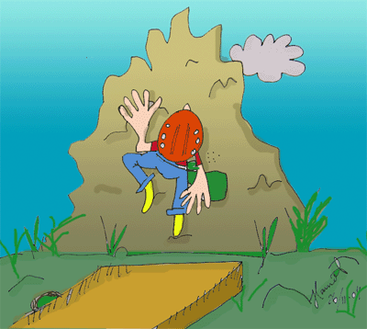

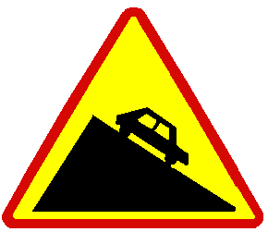
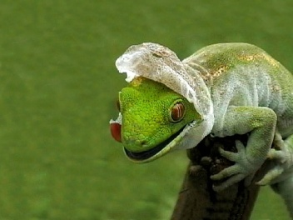

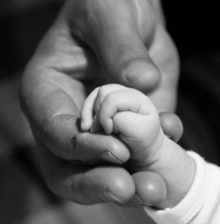

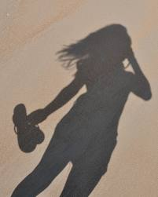

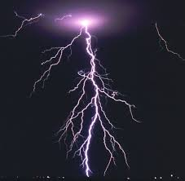

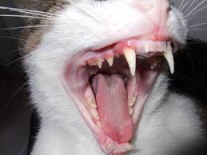
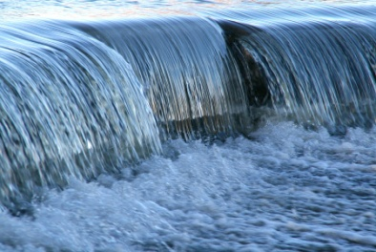

- Use the words from above to complete the sentences.

- The cricket ____________ it’s jacket but had a new one beneath it.

- At night you may see your ____________ in the moonlight.

- The water is ____________ from the stream after the heavy rain.

- The climber will ____________ to the rock as he goes up the mountain.

- The spider uses its ____________ to attack its prey.

- The mouse will ____________ some cheese to eat.

- Volleyball players ____________ the ball with both hands together.

- If you touch a baby you can feel its _________________.

- Human beings have many litres of ____________ in their bodies.

- You can go skiing on a ____________. This allows you to move fast.

- Now, read Desert Voices (DB p.118-119)
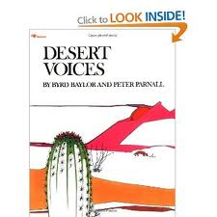
Read the poem and highlight the ten words that you wrote in the spaces in Part B.

